

**Proposal / Application**

**for**

**Final Year Project**

**Computer & Information Systems Engineering Department**

**Live Subtitles using Augmented Reality**

**Ifrah Ishtiaq (CS-17132)**

**Ameema Arif (CS-17122)**

**Mahrukh Khan (CS-17003)**

**Syeda Sara Akif (CS-17002)**

**NED University of Engineering & Technology**

# 

# Project Identification

1. **Reference Number** (for office use only)

|  |  |  |  |  |  |  |
| --- | --- | --- | --- | --- | --- | --- |
| **C** | **S** | **-** | **1** | **7** |  |  |

1. **Project Title**

**Live Subtitles using Augmented Reality**

1. **Project Internal Advisor**

|  |  |
| --- | --- |
| Name | **Miss Fakhra Aftab** |
| Designation | **Lecturer** |

1. **Project Internal Co-Advisor**

|  |  |
| --- | --- |
| Name | **-** |
| Designation | **-** |

1. **Project External Advisor**

|  |  |  |
| --- | --- | --- |
| Name | **-** | |
| Designation | **-** | |
| Organization | **-** | |
| Mobile # | **-** | Email - |

1. **Student Team**

|  |  |  |  |  |
| --- | --- | --- | --- | --- |
| **S.No.** | **Roll No.** | **Name** | **CGPA** | **Email** |
| 1. | CS-132 | Ifrah Ishtiaq | 3.783 | [ifrahishtiaq99@gmail.com](mailto:ifrahishtiaq99@gmail.com) |
| 2. | CS-122 | Ameema Arif | 3.67 | ameema.arif1@gmail.com |
| 3. | CS-003 | Mahrukh Khan | 3.691 | mahrukhkhan150@yahoo.com |
| ~~4.~~ | CS-002 | Syeda Sara Akif | 3.515 | saraakif123@gmail.com |

1. **Sponsoring Organization** (if any)
2. **Keywords**

Augmented Reality, Subtitles, Communication advancement, Speech to Text conversion, Android Application

1. **Project Idea**

** New**  Modification to a previous project  Extension of a previous project

1. **ABSTRACT**

One of the key advantages of technology is to make the communication easier between people by helping them overcome all kinds of different barriers. In our real lives, we are faced with people who cannot comprehend the speaker’s speech due to different reasons such as they may be hearing impaired or simply may not have a command over the spoken language or may not be able to grasp the speaker’s accent. “Live Subtitles” is an approach towards minimizing communication hurdles, which provides real-time speech to text conversion, allowing the users to view and read the speaker’s speech in live conversations. This project is implemented as an android app to ease users in their daily lives. AR allows the text to be overlaid on screen of the user’s mobile. The text may be the content of the speech in either the same language or a different one, translated on the basis of user’s preferred language. This technique of live subtitling is the simplest and most efficient way to share real time content in any language. It also helps to reach a diverse groups of audience and engage with them effectively.

1. **Project Background and Literature Review**

Providing captions or subtitles to live videos is a great help to those who are deaf or hard of hearing as well as it can help people to communicate with people speaking different languages. There are many apps that can generate closed captions and subtitles for recorded videos.

There is a browser based application built using javascript and html. The Face-API API was used to locate faces and facial landmarks and web audio API to text to create the project. This application generates captions in the form of bubbles on the top of the person currently speaking. This can be sometimes exhausting as the viewer has to shift their focus to read the captions throughout the speech.

Some applications are generating live subtitles incorporating augmented reality with the use of Smart Glasses. Initially, a 3D model of the scene set is utilized to fabricate a computerized twin of the physical thing. Next, the computerized twin is lined up with its physical partner using location markers. Subtitles are then added to the computerized variant and all that else is taken out except the inscriptions. This implies that the users won't need to continually switch their concentration between the activities in front them and the inscriptions aside. This is a good solution to this problem, but smart glasses are not affordable for everyone.

We are trying to build such an app that can generate live captions and subtitles. This solution would be more useful, affordable and handy as it can be used anywhere by anyone.

1. **Motivation and Need**

Subtitles are used in all kinds of media for the benefit of all people and to reach every corners of the world. Similarly, Live Subtitles will not only help people with all kinds of disabilities and experiences such as autism spectrum disorder, auditory processing disorders, dyslexia and other intellectual disabilities but also support people with different language preferences in real time.

Live Subtitles increases the retention and the accessibility of the presentation as it allows the users to soak up every word from the speaker, they can engage with him and his content with confidence. Live captions provide reinforcement so they never miss a word, enabling them to

fully absorb the content and feel engaged in the subject matter. With live captioning, the people do not have to try to perform lip reading, straining to follow and trying to grasp the speech at the same time. Such a process is an exhaustive mental load, and live subtitles relieve that burden and allow complete focus and participations.

It offers great support by making access of speaker’s content easier for people; without having them to take their eyes off of the speaker as the video plays a vital role to help people understand and comprehend the information being provided. Hence, here the need becomes clearly visible to make real time videos available to the people having auditory problems and even more for the people to remove the gaps of their

native language and also for having to miss a point while hearing. This can be best done by the use of subtitles in the real-time scenario.

Live captions can be delivered to anybody; people attending an in-person lecture or a formal meeting, people having casual chatting or asking for directions on the way.

1. **Objectives**

This android app is designed to facilitate and enhance the communication process between different individuals. It will allow an increase in the reach of speaker as well as of the user. This will be achieved by developing and implementing the following in the project:

* Audio Extraction from the video
* Audio Decoding into text
* Translation of the text in preferred language
* Display of Subtitles

1. **Methodology and Equipment/Tools**

Live Subtitle Android Application will allow users to view real time speech in textual format in the form of subtitles in their preferred language. The live speech will first be extracted to know the source of speech. It will then be decoded to extract meaning out of it. After translating, it will be displayed to the user in real time using AR.

**Tools:** Android Studio, Vuforia

1. **Key Milestones and Deliverables**

|  |  |  |  |  |
| --- | --- | --- | --- | --- |
| **No.** | | **Elapsed time (in months) from start of the project** | **Milestone** | **Deliverables** |
| 1. | 1 | | Project Proposal | Proposal Document |
| 2. | 2 | | Audio Extraction | Audio File |
| 3. | 3 | | Audio Decoding | Speech Text |
| 4. | 3.5 | | Translation | Translated Text |
| 5. | 4.5 | | Subtitles Display | Subtitles |
| 6. | 6 | | App Development | Android App |
| 7. | 7 | | Integration | Final Application |
| 8. | 8 | | Testing | Test Cases |
| 9. | 8.5 | | Report Writing | Final Report |
| 10. | 9 | | Research Paper Writing | Research Paper |

1. **Expected Outcome**

The project aims to simplify and improvise the procedure of communication. It will provide following outputs:

* Real time display of subtitles in the same or different language, as chosen by the user, on his mobile screen.

1. **Direct Customers / Beneficiaries of the Project**

Although this project will benefit all the people wanting to communicate in real time by providing them subtitles, the most important or direct beneficiaries are:

* People with auditory problems
* People with different language preference

1. **Consent of Advisors**

**Consent of the Internal Advisor** Signature:

**Consent of the Co-Internal Advisor** Signature:

**Consent of the External Advisor (if any)** Signature:

1. **Reviewers Committee’s Comments**

|  |
| --- |
|  |
|  |
|  |
|  |
|  |
|  |
|  |
|  |
|  |
|  |
|  |
|  |
|  |
|  |
|  |
|  |
|  |
|  |
|  |

1. **Project Schedule / Milestone Chart**

*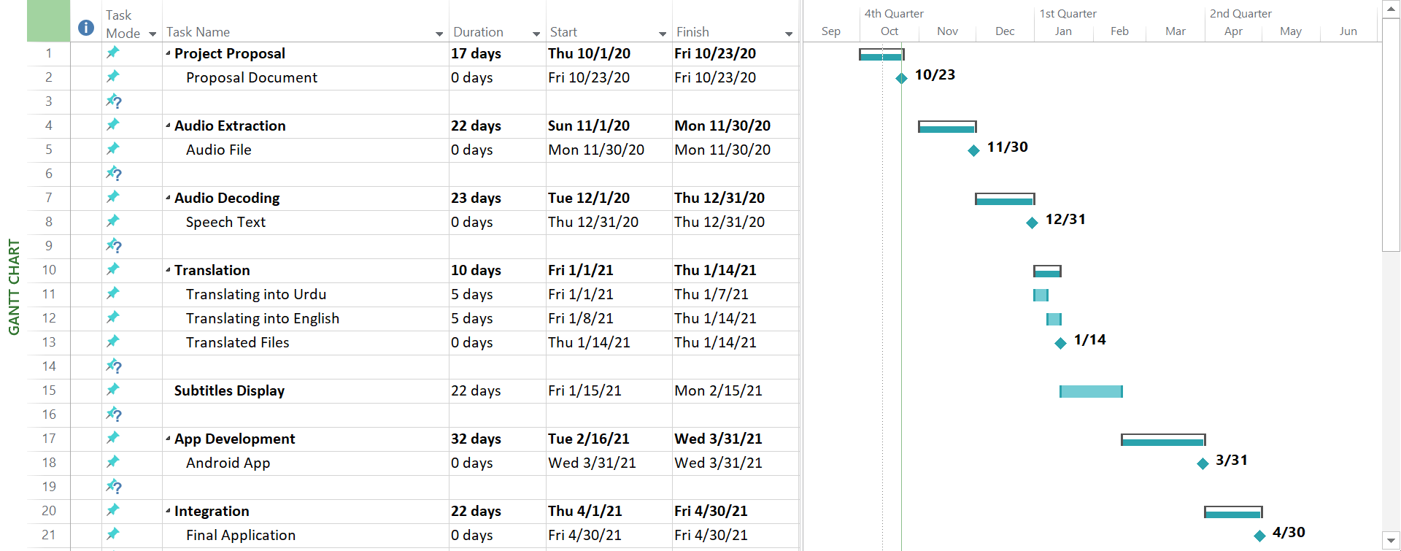.*

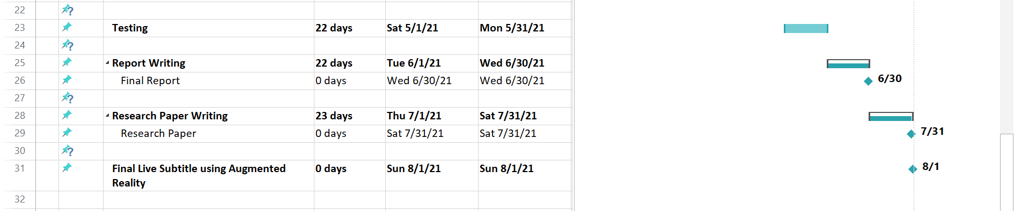

1. **Project Approval Certificate**

**Recommendation of FYP Coordinator** Signature:

**Approval by the Chairman** Signature: